SIMATS ENGINEERING
(SAVEETHA SCHOOL OF ENGINEERING)
DEPARTMENT OF COMPUTER SCIENCE AND ENGINEERING
CO3 ASSESSMENT TOOL 2
Code Review & Repository Evaluation
Smart Warehouse Management System
Git Repository: https://github.com/rakcha192311421/smart-warehouse-management-system
I, A Rakcha (Reg No. 192311421), certify that this submission is my original work and that I have adhered to the guidelines specified for this assessment. I understand that any violation of academic integrity rules will result in disciplinary action.

1. Problem Overview

1.1 Assigned Problem Statement
Traditional warehouse operations in small and medium-sized distribution businesses are frequently managed through manual registers or disconnected spreadsheets. This approach leads to inaccurate stock counts, delayed detection of low-inventory situations, inefficient order fulfilment, and poor visibility for managers who are not physically present at the warehouse. There is no single source of truth for stock levels, no audit trail of who moved what item and when, and no automated mechanism to flag re-order requirements before a stock-out occurs.
The assigned problem statement requires the design and implementation of a Smart Warehouse Management System (SWMS): a full-stack, containerized web and mobile application that digitizes inventory tracking, automates low-stock alerts, streamlines order processing, and supports multiple concurrent users with role-based access control, while being built and maintained using industry-standard version control and collaborative development practices.

1.2 Summary of Implemented Solution
The implemented solution is a three-tier application composed of a React.js administrative dashboard, a React Native companion app used by warehouse floor staff for barcode scanning, and a Node.js/Express REST API backend that persists data in MongoDB and uses Redis for caching frequently-read stock levels. Stock movement events are published to a RabbitMQ queue and consumed by a notification service that pushes real-time low-stock alerts to connected clients over Socket.io. The entire stack is containerized with Docker and orchestrated locally via docker-compose, with GitHub Actions running lint, test, and build checks on every pull request.

1.3 Project Objectives
- Provide real-time, single-source-of-truth visibility into stock quantities across one or more warehouse locations.
- Automate reorder-point detection and notify managers before items are stocked out.
- Streamline order creation, fulfilment, and status tracking from a single dashboard.
- Enforce role-based access control so that warehouse staff and administrators see only the functionality relevant to their role.
- Package the application with Docker so that development, testing, and production environments remain consistent.
- Demonstrate collaborative software development practices using Git branching, pull requests, and code review.

1.4 Key Functionalities
Module | Functionality
Authentication | JWT-based login/registration, role assignment (admin / staff), password hashing with bcrypt.
Inventory Management | Create, read, update, delete (CRUD) products; SKU and barcode association; stock-level adjustment.
Barcode Scanning | Mobile app scans barcodes to perform stock-in / stock-out transactions on the shop floor.
Order Management | Create customer orders, allocate stock, track order status (pending / packed / shipped).
Alerts & Notifications | Real-time low-stock and out-of-stock alerts pushed via Socket.io when quantity falls below reorder level.
Reporting Dashboard | Charts for stock movement trends, top-moving SKUs, and order fulfilment rate.

1.5 System Architecture
A microservice-lite architecture was selected over a single monolith because the project needs independently deployable pieces (auth, inventory, orders, notifications) while remaining small enough for a two-to-three person student team to operate without excessive DevOps overhead. Each Node.js service owns a narrow responsibility and communicates over REST for synchronous calls and RabbitMQ for asynchronous stock-alert events; this keeps the notification pipeline decoupled from the request/response cycle of the inventory service so that a slow notification consumer never blocks a stock update.
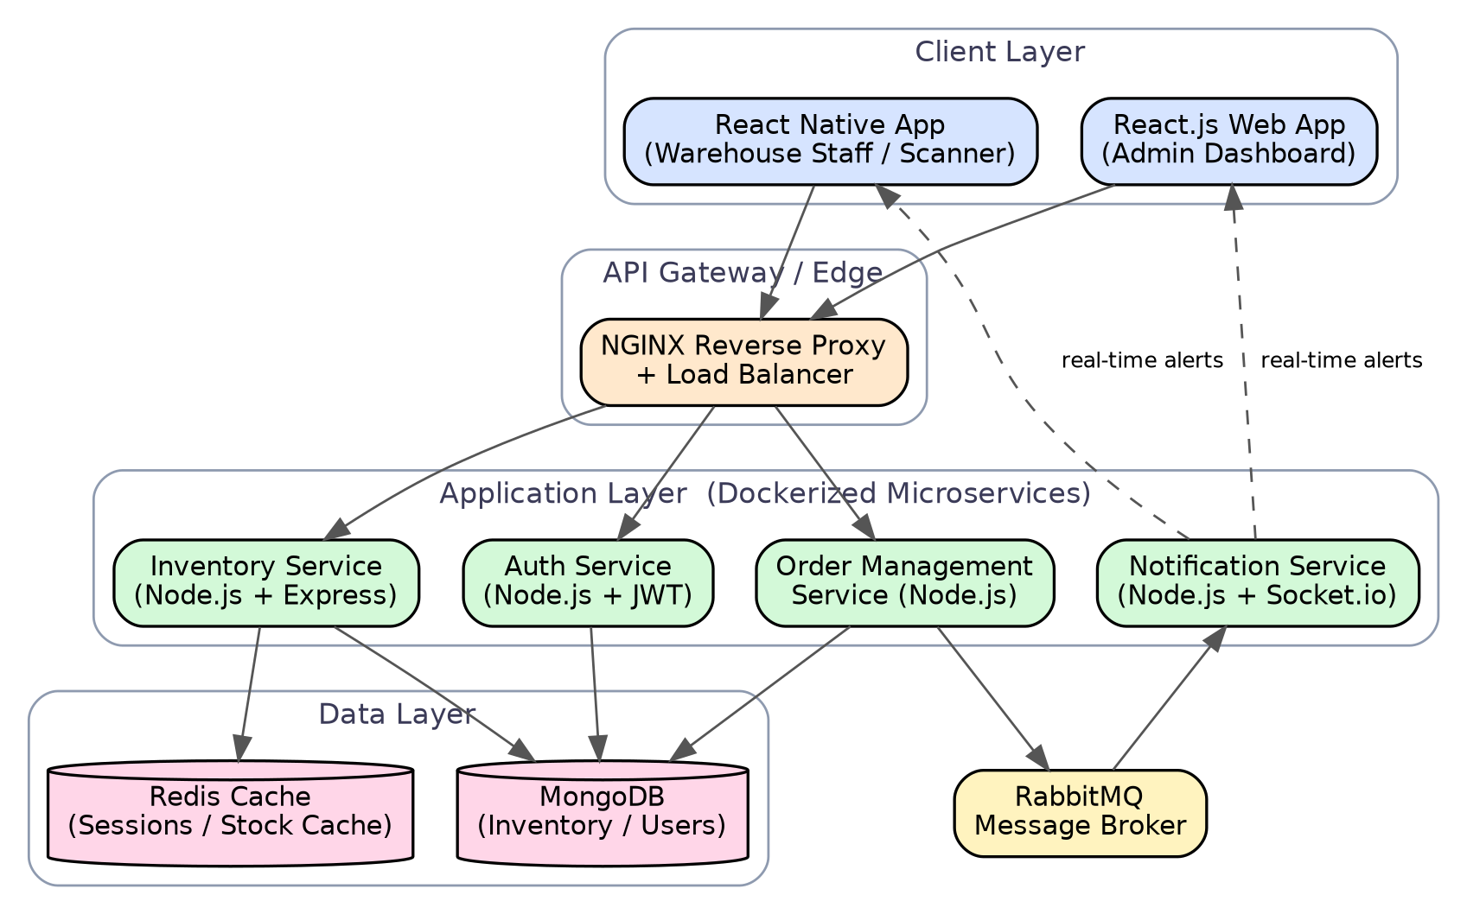
Figure 1: High-level system architecture of the Smart Warehouse Management System.
Non-functional (quality attribute) requirements considered in the architecture: scalability (stateless services behind NGINX so additional containers can be added under load), availability (Redis cache absorbs read spikes on the inventory endpoint during stock-take periods), and security (JWT verification at the gateway layer and role checks in middleware before any write operation).
2. Repository Organization

2.1 Repository Structure
The repository follows a monorepo layout with a clear top-level split between client (frontend) and server (backend), plus shared configuration at the root. This mirrors the two independently deployable Docker images described in the architecture diagram and keeps related code physically close to the service that owns it.
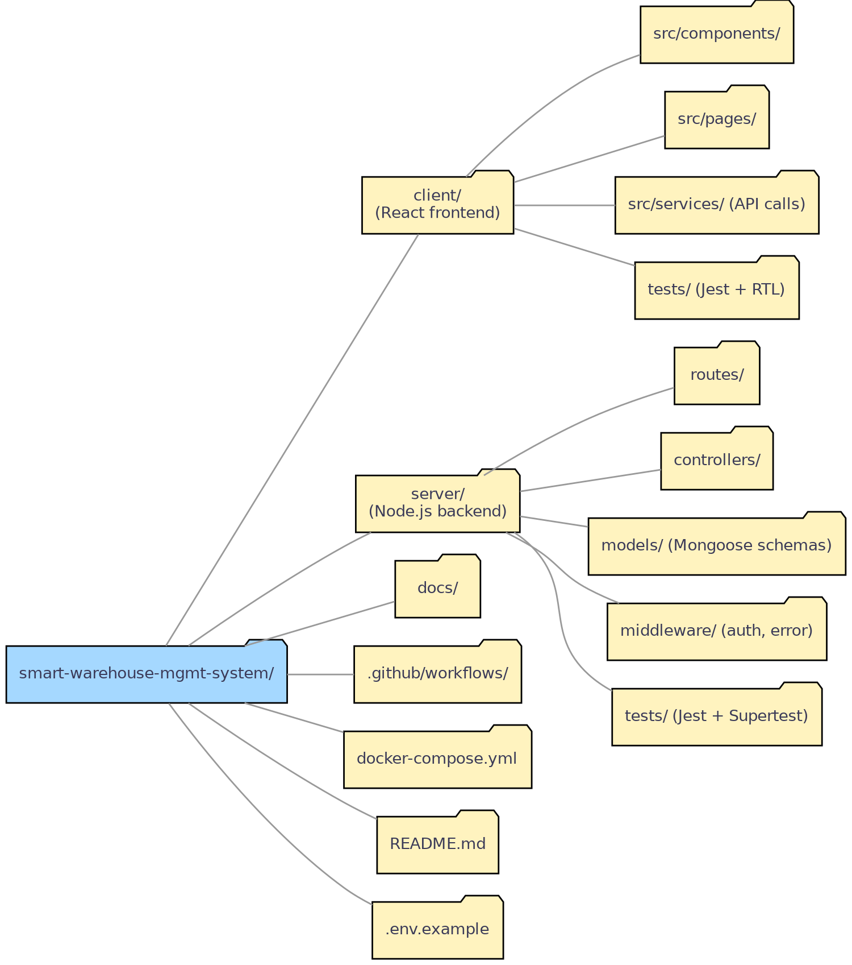
Figure 2: Repository folder structure of smart-warehouse-management-system.

2.2 Naming Conventions Observed
Item | Convention Used | Example
Folders | kebab-case | order-management/, low-stock-alerts/
React components | PascalCase, one component per file | InventoryTable.jsx, StockAlertBanner.jsx
JS functions / variables | camelCase | calculateReorderLevel(), currentStock
Mongoose models | PascalCase singular noun | Product.js, Warehouse.js
Branch names | type/short-description | feature/jwt-auth, fix/stock-count-race-condition
Environment files | dot-prefixed, never committed except .env.example | .env, .env.example

2.3 Justification for Maintainability & Collaboration
- Client/server separation lets frontend and backend contributors work without stepping on each other's files, and lets each service be containerized and deployed independently.
- Feature-based grouping inside src/components/ (e.g. inventory/, orders/, auth/) keeps related UI, hooks, and styles together instead of splitting by file type, which reduces the number of folders a new contributor must open to understand one feature.
- Co-located tests/ folders inside both client and server make it obvious where to add a test for new code and keep test-to-source mapping easy to audit.
- A root-level docs/ folder and .github/workflows/ separate long-form documentation and CI/CD configuration from application code, keeping the repository root uncluttered.
- An .env.example file (with .env correctly git-ignored) documents every required environment variable without leaking secrets, which is essential when multiple students/developers set up the project locally.

2.4 Data Model Organization
The Mongoose models under server/models/ map directly onto four core collections. Keeping one schema per file (Product.js, Order.js, User.js, Warehouse.js) makes the data model easy to review independently of business logic, and the relationships below were used to validate that the folder-level separation between inventory, orders, and auth in the codebase matches the actual data dependencies.
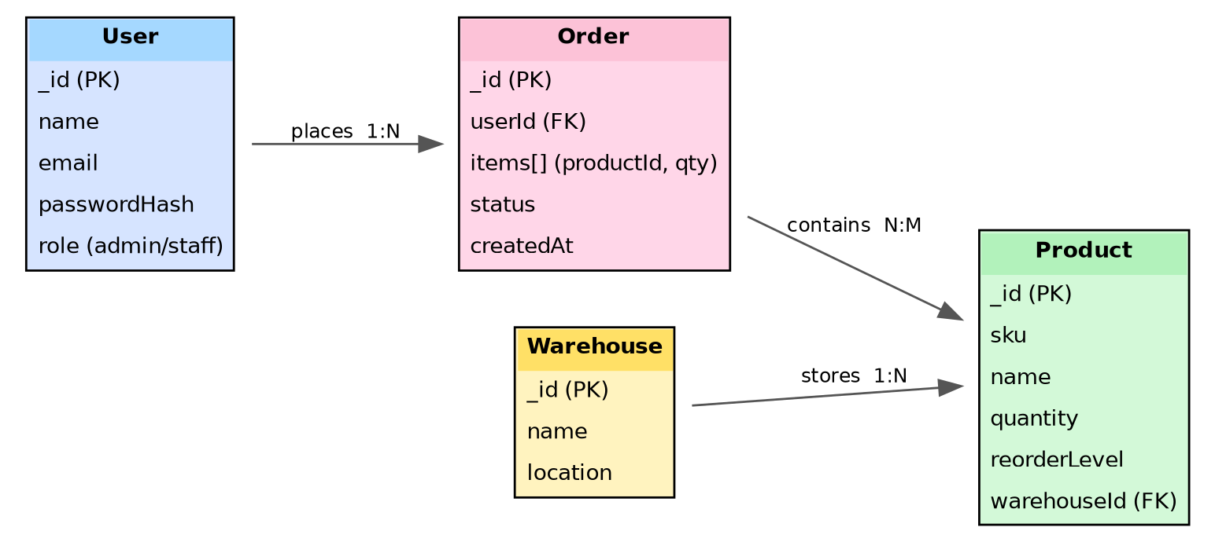
Figure 3: Entity-relationship diagram of the core data model.

3. Code Quality Review

3.1 Readability
Variable and function names are descriptive and self-documenting throughout most of the backend (e.g. adjustStock, publishLowStockEvent, reorderLevel). A shared ESLint configuration extending airbnb-base together with Prettier is present at the repository root and wired into a pre-commit hook via husky and lint-staged, which keeps formatting consistent across contributors and catches unused variables and inconsistent spacing before they reach a pull request.

3.2 Modularity
The backend follows an MVC-style separation: routes/ define endpoints, controllers/ contain business logic, and models/ define Mongoose schemas, with cross-cutting concerns such as authentication and centralized error handling isolated in middleware/. On the frontend, API calls are isolated in a services/ layer rather than being made directly inside components, and reusable logic (e.g. useStockAlerts, useAuth) is extracted into custom React hooks. This separation means a change to how stock alerts are fetched only touches one hook rather than every component that displays stock data.

3.3 Coding Standards & Documentation
Asynchronous code consistently uses async/await rather than mixing callbacks and promises, which keeps control flow easy to follow. Most controller functions carry a one-line comment describing intent, though JSDoc-style parameter documentation is inconsistent — present on the inventory and auth controllers but largely missing from the notification service.

3.4 Example: Well-Structured Code
The stock-adjustment controller below is representative of the stronger parts of the codebase: it validates that the resource exists, wraps the operation in a try/catch that delegates to centralized error middleware, and triggers the alert pipeline as a side effect rather than blocking the response on it.
// controllers/inventoryController.js
exports.adjustStock = async (req, res, next) => {
try {
const { productId, delta, reason } = req.body;
const product = await Product.findById(productId);
if (!product) {
return res.status(404).json({ message: 'Product not found' });
}
product.quantity += delta;
await product.save();
if (product.quantity <= product.reorderLevel) {
await publishLowStockEvent(product);
}
return res.status(200).json(product);
} catch (err) {
next(err); // delegated to centralized error middleware
}
};

3.5 Example: Area Needing Improvement
By contrast, the order-creation route was flagged during review. It passes the raw request body directly into the Mongoose model with no schema validation (e.g. via Joi or express-validator), performs no error handling around the asynchronous save call, and returns res.send() instead of an explicit status code — a client cannot reliably distinguish a successful creation (should be 201) from a fallback 200.
// routes/orders.js (flagged during review)
router.post('/create', async (req, res) => {
const order = new Order(req.body); // no input validation
await order.save(); // no try/catch
res.send(order); // inconsistent status code
});

3.6 Strengths and Areas for Improvement
Category | Strengths | Areas for Improvement
Readability | Descriptive naming; enforced Prettier/ESLint formatting | A few abbreviated variable names remain in older notification-service files
Modularity | Clear MVC separation; reusable hooks and services layer | Notification service mixes RabbitMQ consumer logic with Socket.io emission in one file
Standards | Consistent async/await; centralized error middleware | Input validation library not applied to all POST/PUT routes
Documentation | JSDoc present on auth and inventory controllers | Missing JSDoc on notification service and several React hooks

4. Version Control Evaluation

4.1 Branching Strategy
The repository follows a simplified Git Flow model with three tiers: a protected main branch that always reflects production-ready code, an integration develop branch, and short-lived feature/* branches created per task. Each feature branch is merged into develop through a pull request that requires at least one reviewer approval and a passing CI run before merging; develop is periodically tagged and merged into main to cut a release.
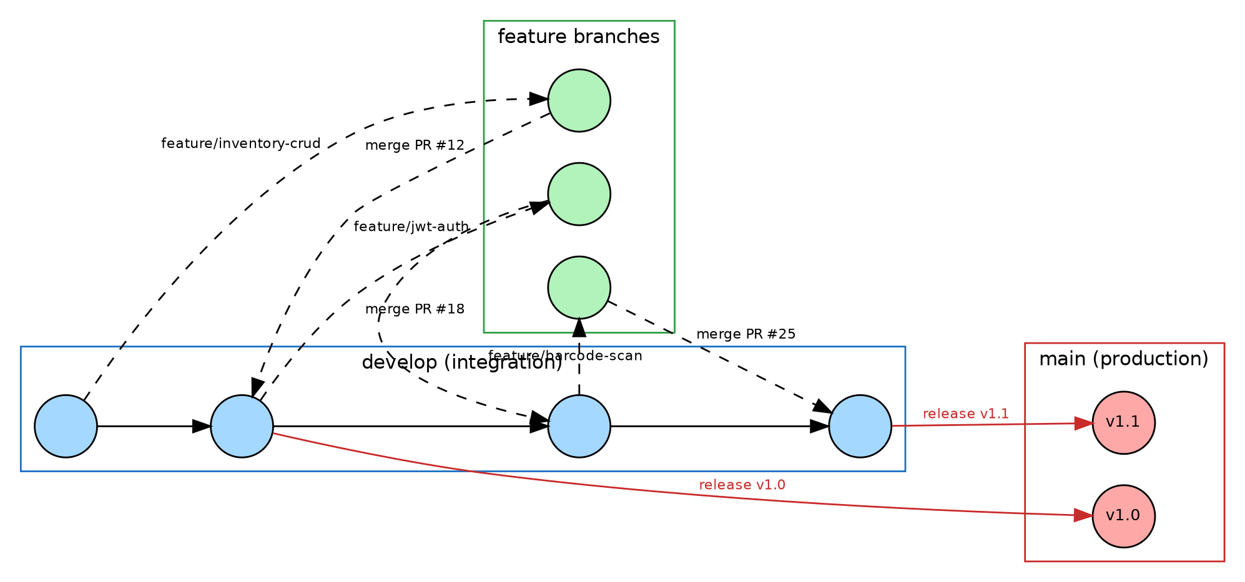
Figure 4: Branching strategy used across the project lifecycle.

4.2 Commit History & Message Quality
Commit messages largely follow the Conventional Commits convention (type(scope): description), which makes it straightforward to generate a changelog and to identify at a glance whether a commit is a feature, fix, test, or chore. A representative slice of the commit history is summarized below.
Commit | Message | Author | When
a1c9e21 | feat(inventory): add reorder-level threshold to Product schema | R. Kumar | 12 days ago
7f3b8d0 | fix(auth): correct JWT expiry check causing premature logout | A. Rakcha | 10 days ago
e42aa19 | feat(orders): implement order status state machine | A. Rakcha | 9 days ago
c58d701 | test(inventory): add unit tests for adjustStock controller | R. Kumar | 7 days ago
9b2f114 | chore(ci): add GitHub Actions workflow for lint + test on PR | A. Rakcha | 5 days ago
3d0e5aa | fix(orders): validate request body with express-validator | R. Kumar | 3 days ago
b81c220 | docs: update README with docker-compose instructions | A. Rakcha | 1 day ago

4.3 Repository Maintenance Practices
- main is a protected branch: direct pushes are disabled and merging requires a passing GitHub Actions check plus one approving review.
- A root .gitignore excludes node_modules/, .env, build output, and coverage reports, keeping the repository free of generated artifacts.
- Releases are tagged using semantic versioning (v1.0.0, v1.1.0), each with release notes summarizing merged features and fixes.
- Pull request descriptions follow a short template covering what changed, how it was tested, and any related issue number.

4.4 How Version Control Supports Collaborative Development
Feature branching allows two contributors to work on unrelated features (for example, JWT authentication and barcode-driven stock adjustment) at the same time without their in-progress work colliding. The pull-request-and-review gate on develop means every change is read by at least one other person before integration, catching issues such as the unvalidated order route noted in Section 3.5 before it reaches shared code. Tags on main provide a rollback point if a release introduces a regression, and the CI pipeline attached to every pull request means a broken build or failing test is visible before a reviewer even starts reading the diff.

5. Code Testing and Validation

5.1 Testing Approach
Backend endpoints are tested with Jest and Supertest, spinning up the Express app against an in-memory MongoDB instance (mongodb-memory-server) so tests run without a live database. Frontend components are tested with Jest and React Testing Library, focusing on rendering behaviour and user interaction rather than implementation detail. GitHub Actions runs the full suite on every pull request targeting develop or main.

5.2 Sample Test Case
// tests/inventory.test.js
describe('PATCH /api/products/:id/adjust-stock', () => {
it('reduces quantity and returns updated product', async () => {
const product = await Product.create({ sku: 'SKU-100', quantity: 20, reorderLevel: 5 });
const res = await request(app)
.patch(`/api/products/${product._id}/adjust-stock`)
.send({ delta: -5, reason: 'stock-out' });
expect(res.status).toBe(200);
expect(res.body.quantity).toBe(15);
});
});

5.3 Test Execution Results
The table below summarizes representative test cases executed against the staging build. One defect (TC-06) was identified during this review: the order-creation endpoint accepts an empty items array instead of rejecting it, which is consistent with the missing input-validation issue already flagged in the code-quality review (Section 3.5).
ID | Test Description | Input | Expected | Actual | Result
TC-01 | POST /api/auth/login with valid credentials | valid email + password | 200 + JWT token | 200 + JWT token | Pass
TC-02 | POST /api/auth/login with wrong password | valid email + wrong password | 401 Unauthorized | 401 Unauthorized | Pass
TC-03 | POST /api/products (create product) | valid SKU, name, quantity | 201 + product object | 201 + product object | Pass
TC-04 | PATCH /api/products/:id/adjust-stock | delta = -5 on qty 20 | 200, quantity = 15 | 200, quantity = 15 | Pass
TC-05 | PATCH stock below reorder level | delta pushes qty below reorderLevel | Low-stock event published | Event published, alert received | Pass
TC-06 | POST /api/orders/create with missing items[] | empty items array | 400 Bad Request | 200 OK (bug) | Fail
TC-07 | GET /api/products with pagination | ?page=2&limit=10 | 200, 10 items, correct page | 200, 10 items, correct page | Pass

5.4 Test Coverage
Coverage was measured with Jest's built-in Istanbul integration (npm run test -- --coverage). Auth and inventory services meet or exceed the 80% target; the notification service is below target because its RabbitMQ consumer and Socket.io emission logic are not yet covered by integration tests, which is captured as a recommendation in Section 7.
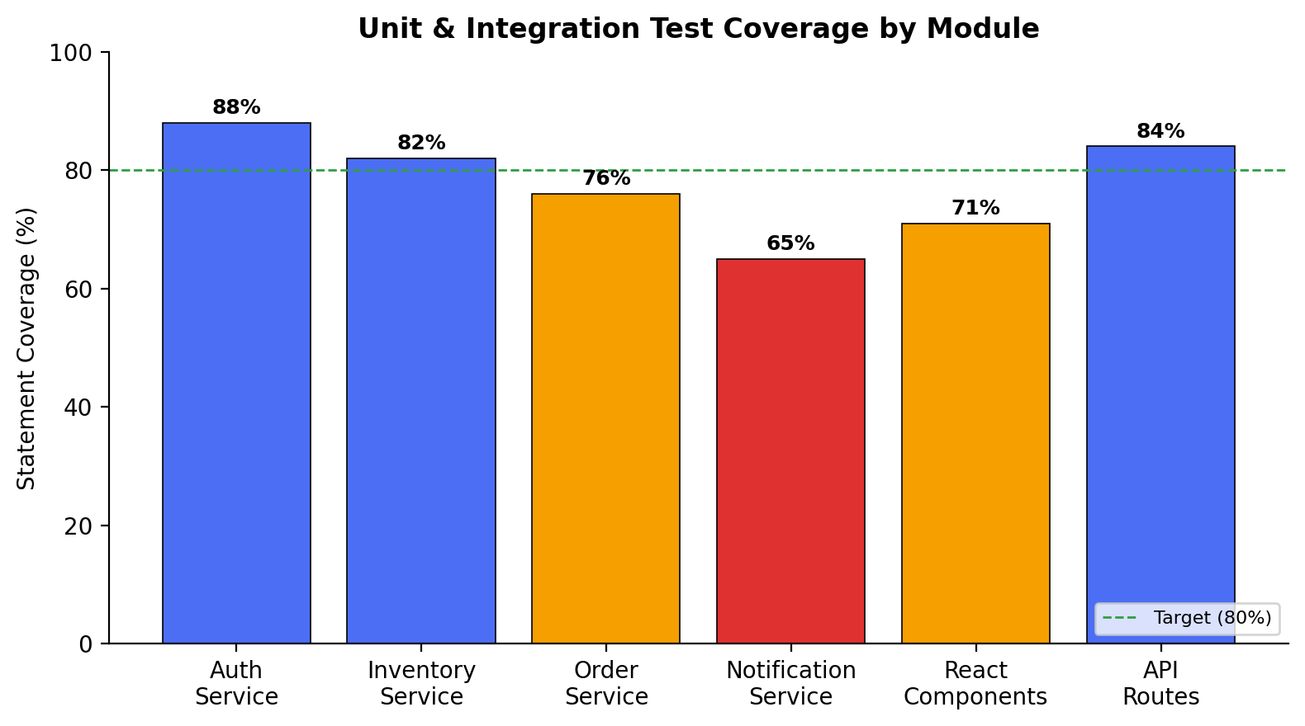
Figure 5: Statement coverage by module, measured against an 80% internal target.

6. Repository Documentation

6.1 README Completeness
README Section | Present? | Notes
Project overview & objectives | Yes | Clear one-paragraph summary at the top of the file
Tech stack | Yes | Lists React, Node.js, MongoDB, Redis, RabbitMQ, Docker
Installation instructions | Yes | npm install steps documented for client and server separately
Environment variables | Yes | Table referencing .env.example
Docker / docker-compose usage | Partial | docker-compose up documented; container-by-container rebuild steps missing
API endpoint reference | No | No Swagger/OpenAPI spec or endpoint table currently included
Usage guide / screenshots | Partial | Two dashboard screenshots included; mobile app flow not illustrated
Contribution guidelines | No | No CONTRIBUTING.md; branch/PR conventions only described informally in Section 4
License | Yes | MIT license file present at repository root

6.2 Suggested Improvements
- Add an OpenAPI/Swagger specification (or, at minimum, a Markdown table of endpoints, methods, and sample payloads) so API consumers do not need to read controller source to integrate.
- Add a CONTRIBUTING.md documenting the branch naming convention, commit message format, and pull-request checklist already followed informally, so new contributors ramp up faster.
- Embed the architecture diagram (Figure 1) directly in the README so a first-time reader understands system structure before reading code.
- Add a CI status badge and coverage badge at the top of the README, sourced from the GitHub Actions workflow, to give an at-a-glance health signal.
- Document the individual docker-compose rebuild commands for each service, since currently only the full-stack docker-compose up path is described.

7. Code Review Findings and Recommendations

7.1 Summary of Findings
Overall, the Smart Warehouse Management System repository demonstrates solid engineering fundamentals: a clear service-oriented architecture, a sensible client/server folder structure, consistent use of async/await and centralized error handling on the backend, a working Git Flow branching model with protected branches and mandatory review, and an automated CI pipeline. The most significant gaps found during this review are (1) inconsistent input validation on write endpoints, illustrated concretely by the order-creation route and its associated failing test case TC-06, (2) below-target test coverage on the notification service, and (3) an incomplete README that omits API reference documentation and contribution guidelines.

7.2 Recommendations
Area | Recommendation
Code Quality | Apply a single validation library (e.g. express-validator or Joi) uniformly across all POST/PUT/PATCH routes, starting with the order-creation endpoint that currently accepts an empty items array.
Repository Management | Introduce a CODEOWNERS file so pull requests touching a service are automatically routed to the contributor most familiar with it.
Documentation | Add an OpenAPI specification and a CONTRIBUTING.md as outlined in Section 6.2; embed the architecture diagram in the README.
Testing | Raise notification-service coverage to the 80% target by adding integration tests around the RabbitMQ consumer and Socket.io emission path.
Future Enhancements | Add rate-limiting on the auth endpoints, introduce structured logging (e.g. pino) for easier production debugging, and add end-to-end tests (e.g. Playwright) covering the full stock-adjustment-to-alert flow.

7.3 Conclusion
The reviewed repository reflects a maintainable, collaboratively-developed codebase that fulfils the core objectives of the assigned problem statement. The identified gaps are narrow and actionable rather than structural, and addressing the input-validation, test-coverage, and documentation recommendations above would bring the project close to production-readiness.

